Portfolio

Virtual Stock Ticker – Front End – Java GUI – Virtual LED Matrix

Robot Soccer Competition – Robot

PyGame – Galaga

FPGA – Slots Machine

**

FPGA – Slots Machine – Hardware

FPGA – Slots Machine – High-Level Drawing

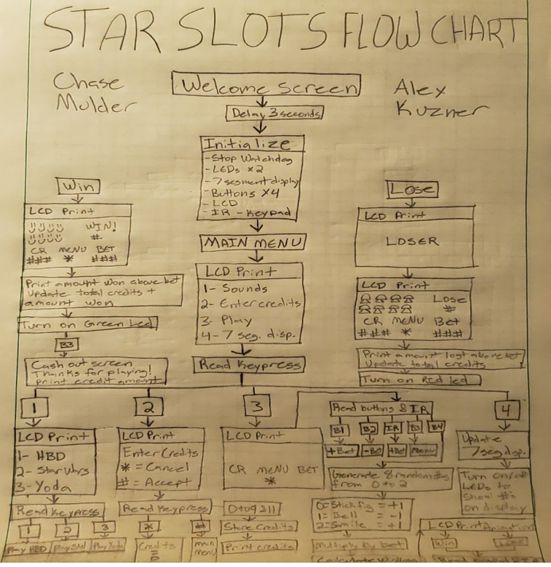

FPGA – Slots Machine – Vivado TCL Code

FPGA – Vending Machine – Software

FPGA – Vending Machine – Software Simulation

Java GUI – Yahtzee

Java – Testing

Circuits I – PCB – Testing

**

Phone Directory – Linux - Vim – C code

Dynamically Sized Vector – Java

Hardest Engineering Physics II Problem

Diffy Q – Final Project

C Code – Encryption From User

TCP Server Multithreading - Python

